**MEET**

**JEREMY**

**Hardin County**

**SKILLS U**

**MISSION:** *The mission of Hardin County Skills U is to provide instructional programs, support, and encouragement to empower all individuals in meeting their educational, personal, career, and family goals.*

**VISION:** *Our vision is to meet the changing needs of the community by continuously developing, monitoring, and improving our programs and services.*

**VALUES:** *We value the uniqueness of all individuals and the contributions they make in our community.*

**HARDIN COUNTY SKILLS U**

***A Hardin County Chamber Member***

**serving businesses, industries, community partners, and residents of Hardin County**

located at

Elizabethtown Community and Technical College

**E C T C**

OTB Room 310

600 College Street Rd

Elizabethtown, KY 42701

***(270) 769-8866***

***or***

***(270) 769-8875***

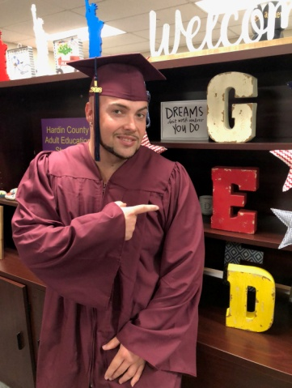

Hardin County SKILLS U

Director: *Diane Kelley*

*diane.kelley@hardin.kyschools.us*

**270-706-8017**

**Cell 270-304-4893**

**Main Office**

Elizabethtown Community and Technical College

(ECTC)

OTB Room 310

Elizabethtown, KY 42701

**(270)769-8866 or (270)769-8875**

[**website**](http://www.hardin.kyschools.us/adulted/)[**www.hardin.kyschools.us/adulted/**](http://www.hardin.kyschools.us/adulted/)

**https://www.facebook.com/hardincountyadulteducation**

**Classes in Elizabethtown (two locations)**

**and Radcliff**



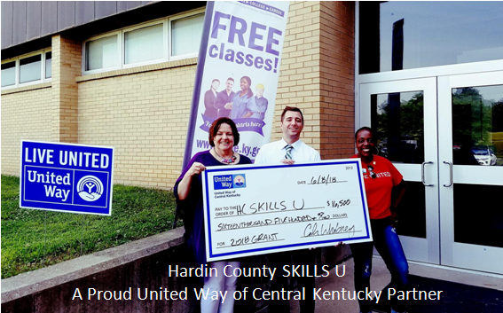dollar general.PNG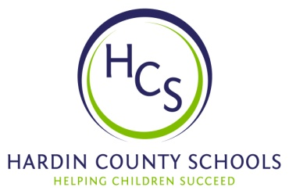

***Jeremy is a steadfast and dedicated learner who took advantage of our EMPOWER Success Coach services (funded by the United Way of Central Kentucky). The one-on-one tutoring with wrap-around services coupled with SKILLS U classes helped Jeremy overcome obstacles and***

***EARN HIS GED!***

***He plans to attend ECTC in the spring of 2019***