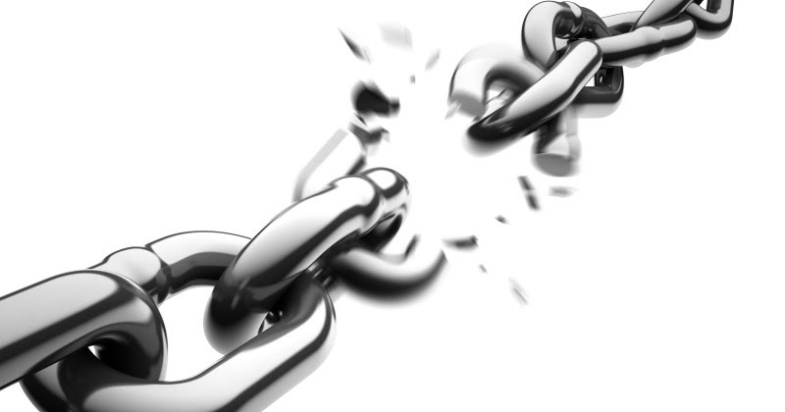

Cycle

Break the



**Program/County Name**

**Address**

**City, KY zip**

**phone number here**

***We are here to help you build a better, brighter future!***

***We are here to help you build a better, brighter future!***

**We Offer FREE services to help you:**

* **Earn a GED® diploma**
* **GED®+ program**
* **Prepare for college/training**
* **Earn job-related certifications**
* **Increase employability skills**
* **And much more!**

**Contact us today to find out more!**

**We Offer FREE services to help you:**

* **Earn a GED® diploma**
* **GED®+ program**
* **Prepare for college/training**
* **Earn job-related certifications**
* **Increase employability skills**
* **And much more!**



Break the



**Program/County Name**

**Address**

**City, KY zip**

**phone number here**

**Contact us today to find out more!**

Cycle